Data Flow Diagram & User Stories
Project Design Phase-II

Date | 12/09/2026
Student Name | Navya Sri Tangellamudi
Project Name | Intergalactic Space Travel Request System (ISTR)
Maximum Marks | 4 Marks

Data Flow Diagram
The diagram below shows the Level 0 data flow for the ISTR system: how a mission request enters the system from the Requester, moves through automated approval routing (Manager, Finance Officer, and — for High/Critical risk missions — Mission Control), is written to and read from the u_space_travel_request table and the audit/SLA log, and results in a launch action and stakeholder notifications.
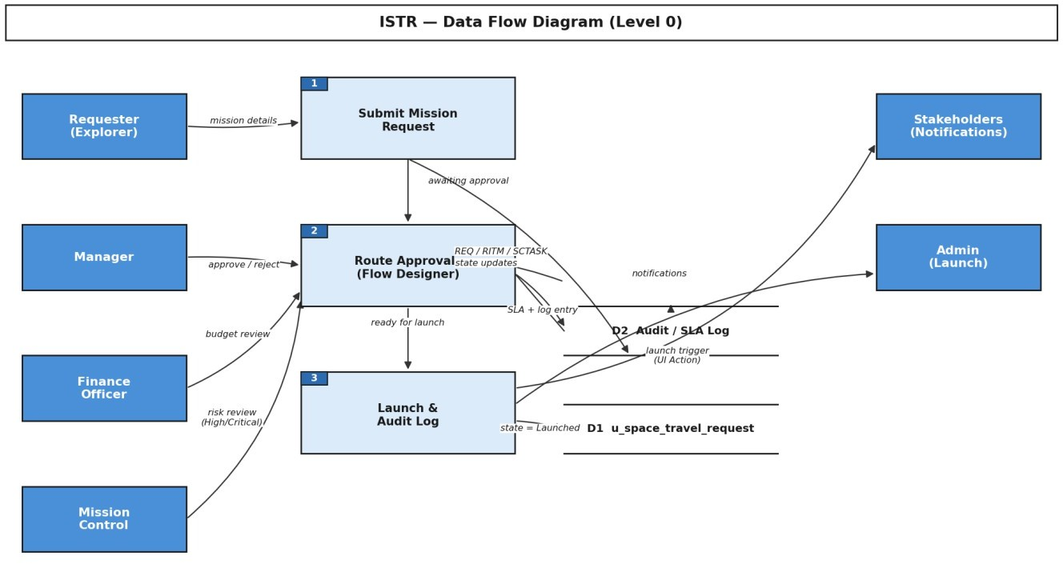

Figure 1 — ISTR Level 0 Data Flow Diagram

Actor–System Context Diagram
Complementing the data flow view, the context diagram below frames ISTR from the outside in: every actor that interacts with the system and the nature of that interaction, independent of the internal processing steps.

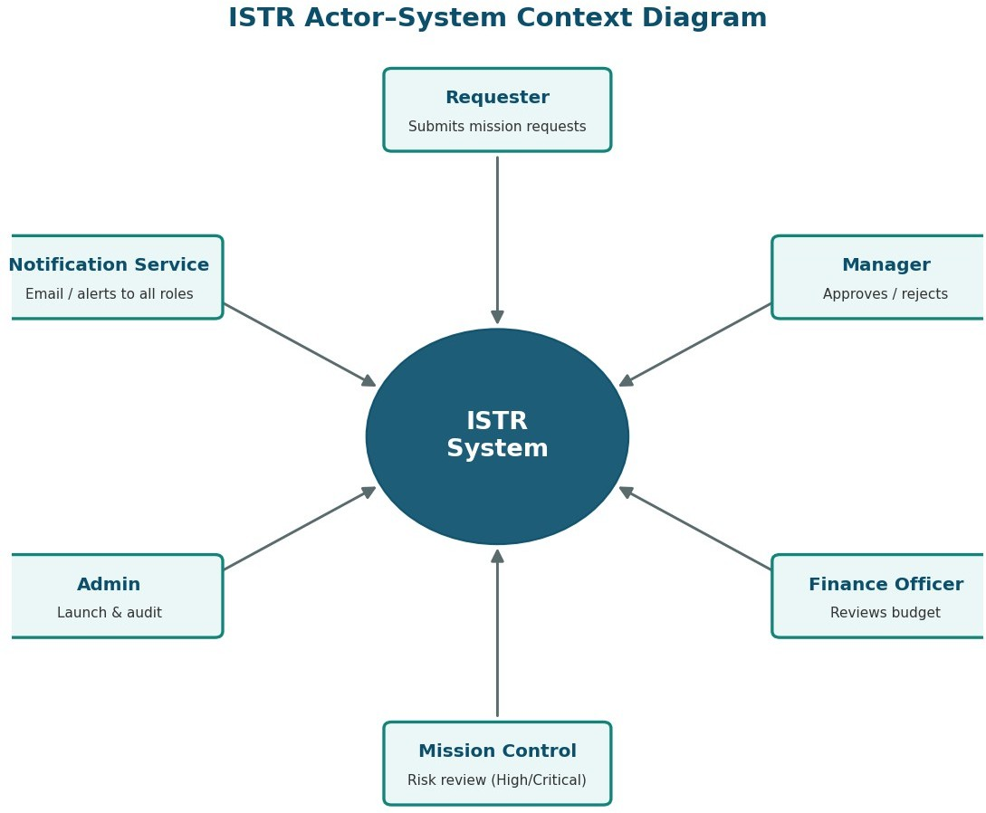

Figure 2 — ISTR Actor–System Context Diagram

User Stories
The table below lists the user stories for the ISTR product, grouped by user type and functional requirement (epic), with acceptance criteria, priority, and target release.

User Type | Functional Requirement (Epic) | USN | User Story / Task | Acceptance Criteria | Priority | Release
Requester (Explorer) | Mission Request Submission | USN-1 | As a Requester, I can submit a Mission Request by entering destination, mission type, risk level, cost estimate, and launch date. | A REQ/RITM/SCTASK record is created in u_space_travel_request with state 'Awaiting Manager Approval'. | High | Sprint-1
 |  | USN-2 | As a Requester, I can see additional fields appear when I select 'Alien Negotiation' as the mission type. | A Diplomatic Officer field becomes mandatory and visible only for that mission type. | Medium | Sprint-1
 |  | USN-3 | As a Requester, I receive an email confirmation once my request is submitted. | Confirmation email is sent with request number and current status. | High | Sprint-1
 |  | USN-4 | As a Requester, I can track the live status of my request on a personal dashboard. | Dashboard shows current stage, approver, and SLA countdown. | Medium | Sprint-2
Manager | Approval Routing | USN-5 | As a Manager, I am automatically notified when a direct report submits a mission request. | Flow Designer looks up the requester's manager and routes the approval task to them. | High | Sprint-1
 |  | USN-6 | As a Manager, I can approve or reject a request with comments. | Approval/rejection updates the state and logs the comment in the audit trail. | High | Sprint-1
 |  | USN-7 | As a Manager, I am reminded if I have not actioned a request within the SLA window. | An escalation notification is sent at 80% of SLA duration. | Medium | Sprint-2
Finance Officer | Budget Review | USN-8 | As a Finance Officer, I can review and adjust the estimated mission cost. | Cost field is editable only by the space.finance role; changes are logged. | High | Sprint-1
 |  | USN-9 | As a Finance Officer, I can approve the budget so the request proceeds to the next stage. | On approval, state moves to 'Awaiting Mission Control' (if High/Critical risk) or 'Ready for Launch'. | High | Sprint-2

User Type | Functional Requirement (Epic) | USN | User Story / Task | Acceptance Criteria | Priority | Release
Mission Control | Risk Assessment | USN-10 | As a Mission Control reviewer, I only see requests flagged High or Critical risk in my queue. | ACL and filter restrict the queue to risk-qualified records. | High | Sprint-2
 |  | USN-11 | As a Mission Control reviewer, I can request additional information before approving. | Record is returned to the Requester with a comment; state reverts to 'Draft'. | Medium | Sprint-2
Administrato r | Launch Execution | USN-12 | As an Admin, I can trigger the 'Launch Mission' UI action only when a request is fully approved. | Action is visible only when state = 'Ready for Launch' and role = space.admin. | High | Sprint-3
 |  | USN-13 | As an Admin, I can view a complete audit log of every state change and approval. | Audit related list shows timestamp, user, old value, and new value for each change. | Medium | Sprint-3
All Stakeholders | Notifications & Dashboard | USN-14 | As a stakeholder, I receive a real-time notification whenever a mission I'm involved in changes state. | Email/Slack-style notification fires on every state transition. | Medium | Sprint-3
 |  | USN-15 | As a stakeholder, I can view a role-specific dashboard showing only the missions relevant to me. | Dashboard widgets are filtered by role (Requester, Manager, Finance, Mission Control, Admin). | Low | Sprint-3

User Story Distribution
15 stories are spread across three sprints and three priority levels. Sprint-1 is intentionally the heaviest, front-loading the core submission-to-approval path so later sprints build on a working foundation; High-priority stories dominate the backlog, reflecting that most of ISTR's value sits in the core workflow rather than the peripheral notification/dashboard layer.
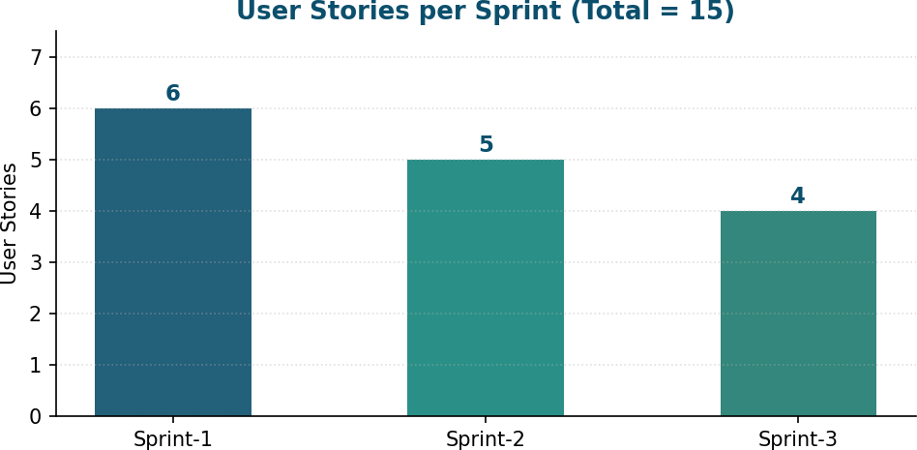
Figure 3 — User Stories per Sprint
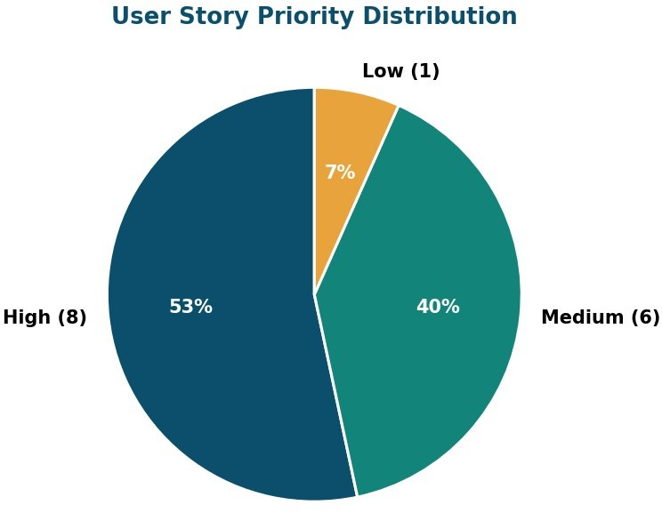

Figure 4 — User Story Priority Distribution

